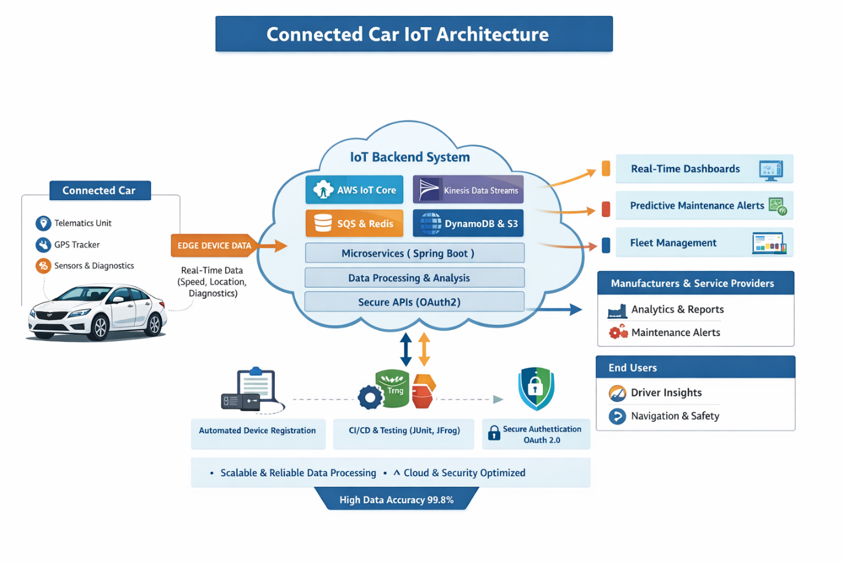

1. Connected Car (Edge Layer)
This is the data source, located inside the vehicle.
a. Telematics Unit
- An embedded computing and communication module inside the car
- Collects vehicle data and sends it to the cloud via cellular network (4G/5G)
- Acts as the gateway between the vehicle and the cloud
b. GPS Tracker
- Captures real-time location, speed, and route information
- Enables:
  - Live tracking
  - Navigation
  - Geofencing
  - Theft detection
c. Sensors & Diagnostics
- Vehicle sensors (engine, battery, brakes, temperature, fuel, etc.)
- On-Board Diagnostics (OBD-II) data
- Used for:
  - Vehicle health monitoring
  - Fault detection
  - Predictive maintenance
✅ Output:
Edge Device Data such as speed, location, fuel level, fault codes, and diagnostics.

2. Edge Device Data Transmission
- Data is streamed in real time from the car to the cloud
- Typically uses:
  - MQTT / HTTPS
  - Cellular network
- Designed for low latency and reliability

3. IoT Backend System (Cloud Layer)
This is the core intelligence layer, hosted on the cloud.

a. AWS IoT Core
- Secure device connectivity and message ingestion
- Handles:
  - Device authentication
  - Secure message routing
  - MQTT topics
- Acts as the entry point for all car data

b. Kinesis Data Streams
- Handles real-time streaming data
- Used for:
  - Live telemetry processing
  - Streaming analytics
- Ensures scalability for millions of events per second

c. SQS & Redis
- Amazon SQS (Queue):
  - Decouples services
  - Ensures reliable message delivery
- Redis (In-memory cache):
  - Ultra-fast access to frequently used data
  - Improves performance of dashboards and APIs

d. DynamoDB & S3
- DynamoDB:
  - NoSQL database for fast read/write
  - Stores vehicle metadata, states, alerts
- Amazon S3:
  - Long-term storage
  - Used for raw telemetry, logs, and analytics data

e. Microservices (Spring Boot)
- Application logic is broken into small independent services
- Each microservice handles:
  - Fleet management
  - Alerts
  - User profiles
  - Vehicle diagnostics
- Improves scalability and maintainability

f. Data Processing & Analysis
- Cleans, transforms, and analyzes incoming data
- Enables:
  - Anomaly detection
  - Predictive maintenance
  - Usage analytics
- Often uses rules engines or ML models

g. Secure APIs (OAuth 2.0)
- Exposes data securely to external apps
- Ensures:
  - Authentication
  - Authorization
- Used by dashboards, mobile apps, and partners

4. CI/CD, Security & Operations Layer
Found below the cloud in the diagram.
a. Automated Device Registration
- Onboards new vehicles automatically
- Each vehicle gets:
  - Unique identity
  - Certificates/keys

b. CI/CD & Testing (JUnit, JFrog)
- Continuous integration and delivery
- Automated testing ensures:
  - Code quality
  - Faster deployments
  - Reduced downtime

c. Secure Authentication (OAuth 2.0)
- User and service authentication
- Prevents unauthorized access
- Supports token-based security

5. Outputs & Consumers (Right Side)
These are the users of processed data.

a. Real-Time Dashboards
- Visualize live data:
  - Speed
  - Location
  - Vehicle status
- Used by operations teams

b. Predictive Maintenance Alerts
- AI/ML-driven alerts
- Predict failures before they occur
- Reduces breakdowns and maintenance costs

c. Fleet Management
- Manage multiple vehicles
- Features:
  - Route optimization
  - Driver performance
  - Utilization reports

6. External Stakeholders
a. Manufacturers & Service Providers
- Access analytics and reports
- Receive maintenance alerts
- Improve vehicle design and service quality

b. End Users (Drivers)
- Driver Insights:
  - Driving behavior
  - Fuel efficiency
- Navigation & Safety:
  - Real-time navigation
  - Safety warnings

7. Non-Functional Characteristics (Bottom)
Scalable & Reliable Data Processing
- Handles millions of vehicles
- Fault-tolerant architecture
Cloud & Security Optimized
- Encryption
- Authentication
- High availability
High Data Accuracy (99.8%)
- Ensures trust in analytics and decisions

✅ Overall Data Flow Summary
Car Sensors → IoT Core → Streaming & Storage → Processing & Analytics
→ Secure APIs → Dashboards / Alerts / Users

